 | II ALL-BELARUSIAN FESTIVAL OF FOLK ART “BELARUS — MY SONG”  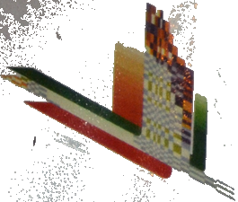 | 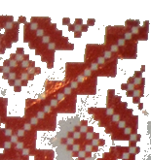
CERTIFICATE OF HONOR
AWARDED TO
TARASIUK MIKALAI
(Pruzhany District)
FOR PARTICIPATION IN THE REGIONAL
EXHIBITION OF FOLK ART
“Colors of the Polesian Land”
 |  | ORGANIZING COMMITTEE
BREST 2005
