Ger. Maiden name
Family Book
L
S c h e i l
Surname of the husband
K o t t e n r o d t
Maiden name of the wife
1. Husband: 2. Wife:
/- | Surname  before marriage | Kottenrodt -/-
/- | First names | Gunde -/-
student nurse -/- | Occupation | Nursery nurse -/-
er 1943 -/- | Date of birth | 13 October 1947 -/-
-/_ | Place of birth | Freiburg im Breisgau -/-
No. 6478/1943 -/- | Registry Office, No. | Freiburg im Breisgau No. 1825/1947
ch -/- |  | Protestant -/-
 | Basis of the  entry | -/-
Date and place of marriage | 12 June 1970, Freiburg im Breisgau -/-
r entry | Marriage entry No. 565 -/-
4. Parents of the husband: 5. Parents of the wife:
Scheil -/- | Surname | Father:  Kottenrodt -/-
ius Ferdinand -/- | First names | Ulrich Wolfgang Martin -/-
tgart -/- | Place of residence or  last place of residence | resident in Ebnet, District of Freiburg im
 |  | Breisgau -/-
. Wagner -/- | Surname | Mother:  Kottenrodt née Köhler -/-
 |  | -/-
-/- | First names | Margarete -/-
tuttgart -/- | Place of residence or  last place of residence | resident in Ebnet -/-
u 1 -/- | Basis of the  entry | Birth cert. for 2 -/-
1 intermediate line -/-   | Freiburg im Breisgau , the 12 June 1970  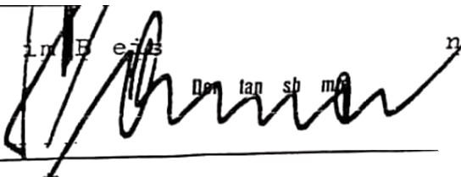 The Registrar  (Sonner) Ma
7. Note on the nationality of the spouses and proof
. National, Nationality ID of the
ttgart dated 5 June 1970. The 26
The Registrar p.p.
 (Symanczick)

