MARRIAGE CERTIFICATE  MARRIAGE CERTIFICATE  (surname — surname,  name and patronymic — name and patronymic)  (place of birth — place of birth)  (surname — surname,  name and patronymic — name and patronymic)  (place of birth — place of birth)  (year, month and day — to be filled in both  in words and figures — year, month and day in words and figures)  year) | about which in the civil status act register  concerning  of which in the civil status act register  of marriage  Surnames assigned after marriage registration:  Upon registration of marriage, the following surnames were assigned:  (name and location of the ZAGS bureau —  name and location of the ZAGS bureau)
  Citizen  Cit. | Musabekov
  Yerbolat Nigmanovich
  1946 | year of birth  year of birth
  Chuysky District
  Dzhambul Region
  ethnicity  ethnicity | Kazakh
  and citizen  and citizen | Bolayeva
  Zhamal Alimovna
  1948 | year of birth  year of birth
  Chuysky District
  Dzhambul Region
  ethnicity  ethnicity | Kazakh
  entered into marriage  entered into marriage | 16/XI-68г. (six-
  teenth of November
  one thousand nine hundred
  sixty-eighth
  1968 | year  year | November | month  month | 16 | day  day
  the corresponding entry was made in the registration book  the corresponding entry was made under | No. | 1404
  to the husband  to the husband | Musabekov
  to the wife  to the wife | Musabekova
  Place of registration  Place of registration. | Alma-Ata
  Frunzensky
  District Civil Registry Office
  Date of issue  Date of issue | " | 16 | “ November | 1968 | y.  y.
  31 | L. S.  L. S.   | IV-КА № 026588  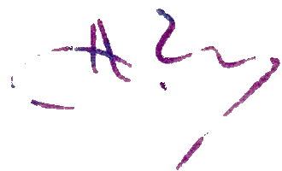  Civil status act registration  bureau head  Head of the registration bureau  of civil status acts

