DIPLOMA.
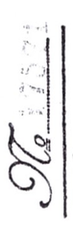 | The bearer hereof, Alfred Yanovich Birznek, of the Evangelical Lutheran confession, of the peasant class, while a student of the Faculty of Law of the IMPERIAL Moscow University, underwent in the years 1908, 1909, 1910, and 1911 the established mid-course examinations and, upon the Faculty's credit of the number of semesters determined by the Statute, was admitted in the spring of 1912, according to his petition, to the examinations in the Legal Examination Commission at this University, which examinations he passed.  At the said examinations, he received the following marks:  1) At the examinations of the first half of the university course: in encyclopedia of law very satisfactory, in history of Roman law very satisfactory, in history of Russian law very satisfactory, in history of philosophy of law satisfactory, in political economy very satisfactory, in statistics very satisfactory, in state law very satisfactory, in church law very satisfactory.  In local civil law very satisfactory, in forensic medicine very satisfactory.  2) At the examinations in the Commission: in criminal law very satisfactory, in criminal procedure satisfactory, in civil law very satisfactory, in civil procedure very satisfactory, in Roman law very satisfactory, in international law satisfactory, in commercial law very satisfactory, in financial law very satisfactory, in administrative law very satisfactory.  Wherefore, and on the basis of Art. 81 of the General Statute of the IMPERIAL Russian Universities of August 23, 1884, and upon approval of the submitted thesis, Mr. Birznek, in the session of the Legal Examination Commission on June 1, 1912, was awarded a First-Class diploma, with all the rights and privileges enumerated in Art. 92 of the Statute and in Paragraph V of the opinion of the State Council, sanctioned by HIS IMPERIAL MAJESTY on the 23rd day of August 1884. In witness whereof, this diploma is granted to Mr. Birznek, under the proper signature and with the seal of the Administration of the Moscow Educational District affixed,  City of Moscow, April 20, 1913.
 | Trustee of the Moscow Educational District | 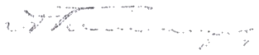
 | Chairman of the Legal  Examination Commission | 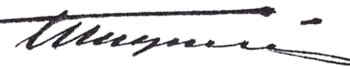
 | Head of the Chancery | 