BIRTH CERTIFICATE  BIRTH CERTIFICATE  Place of birth: city, settlement  Place of birth: city, village  about which in the birth registration book  about this in the birth registration book | PARENTS  PARENTS  7
  Citizen | Ibragimov
  Citizen | surname — surname,
  Mirzaolim Ibragimovich
  name, patronymic — name, father's name
  was born | May 10, 1928
  was born | day, month, year — year, month, day
  One thousand nine hundred
  (in figures and in words — in words and in figures)
  twenty-eighth year
  Zarkent v/c
  district | Yangikurgan
  region | Namangan
  republic | Uzbek SSR
  19 | 51 | year | January | month | 10 | day
   |  | year |  | month |  | day
  entry made under No. | 46 | was recorded.
  Father | Beknazarov
  Father | surname — surname,
  Ibragim
  name, patronymic — name, father's name
  ethnicity | Uzbek
  ethnicity
  Mother | Beknazarova
  Mother | surname — surname,
  Agakhon
  name, patronymic — name, father's name
  ethnicity | Uzbek
  ethnicity
  Place of registration | Uzbek SSR Namangan
  Place of registration | name and location of the body
  region Yangikurgan
  Civil Registry Office — name and location of the Civil Registry Office
  district Civil Registry department
  Date of issue | February 26, 1973 | y.
  Time of issue |  | y.
  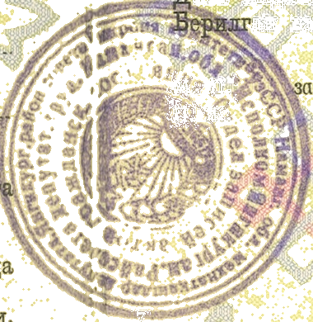 | Head of department (bureau)  L. S. of the civil status acts registration  L. S. of the civil status acts  registration department (bureau) head  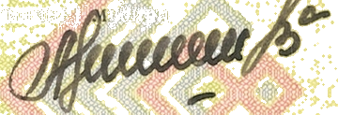  I-ЧА № 367288

